Overview
Contour lines are an incredible difficult concept to grasp, especially considering the conventional representation of a three-dimensional space on a two-dimensional piece of paper. This guided lesson takes advantages of Minecraft’s terrain capabilities and empowers students to trace contour lines along elevation changes on an island.

Screenshots
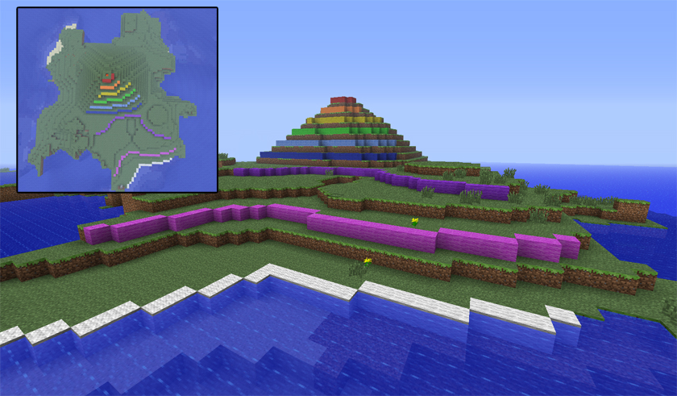
The two views of the island that this lesson emphasizes: the “ground level” and “bird’s eye” views

Objective
The objective is to fully immerse students in a three-dimensional world and encourage them to navigate the space around contour lines. By navigating around the space after tracing the contour lines, students will begin to understand the relationship of elevation changes and contour lines. In particular, students will interact with the relationship of elevation and color, as well as the relationship of distance between lines and steepness of elevation.

This lesson is a supplement to existing coursework related to contour lines. This lesson also assumes that students have a loose understanding of contour lines, or at least have been introduced to the concept.

Activities
Students enter the lesson on one part of an island, open a chest to choose a color of dyed wool, and trace the elevation changes around this contained space with the colored wool. Each elevation change is denoted with a different color of wool and a small sign indicates the current distance, in blocks, above sea level on a particular elevation.
After tracing the island all the way around, the students may fly up and look at the island from the top, reinforcing the connection of mapping a terrain with contour lines.

Lesson Plan
Preparation
In World Options in the Teacher Menu, ensure that “Allow Day/Night Cycle” is toggled off and “Students can build” is toggled on. This is necessary so that students can trace with the colored wool. Also ensure that the chest is filled with the assortment of wool.
Starting the Lesson
Students will enter the lesson on top of the black and white checked block, known as the Spawn block.
Guide students toward the chest (which can be opened with Right Click) and have them choose a color of wool.
The bottom elevations will require more tracing so encourage students to collaborate for the lower elevations, particularly the white, magenta, and purple elevations.
Adjusting for completion speed
If some students are progressing faster than others, encourage those students to fill in the island with the appropriate colors, or ask them check the rest of the island for any inconsistencies with the coloring.
Ending the lesson
Once all students have traced the mountain, toggle “Creative Mode” (Teacher Menu -> General Options) and instruct students to fly above the island and look down at their work. Students can be teleported to the observation deck prior to giving them “Creative Mode.” This is a great opportunity for reflection since they can see the contour lines on the 3D terrain.
Suggested Reflection questions
- Look at the parts of the island that have their contour lines closer together. What does that mean? What do lines that are further apart mean?
- Why are different colors used?
- Why is it important to know the contour of a map?
- What surprised you about the process?

Support Files
The next page is a student handout that contains key information relating to Minecraft.
Contour lines provide an incredible amount of detail about anything from elevation to sea depth, or even to air quality and noise pollution. These lines simply join points of equal value. For elevation, contour lines represent points of equal elevation above sea level.
In this lesson you will trace contour lines in a 3D space within Minecraft. Take careful note of the signs that label the current elevation. A properly labeled map helps the reader quickly interpret the shape of the terrain.
To start tracing the lines, open the chest with Right Click and choose one of the colors of wool. Remember to work together and collaborate with your classmates!
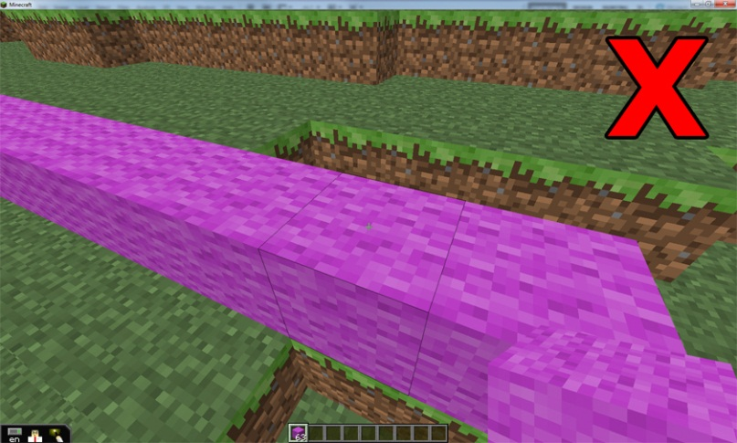
Choose the elevation that matches the color you selected and begin to trace the outside. Trace as closely as you can to the side of the land!

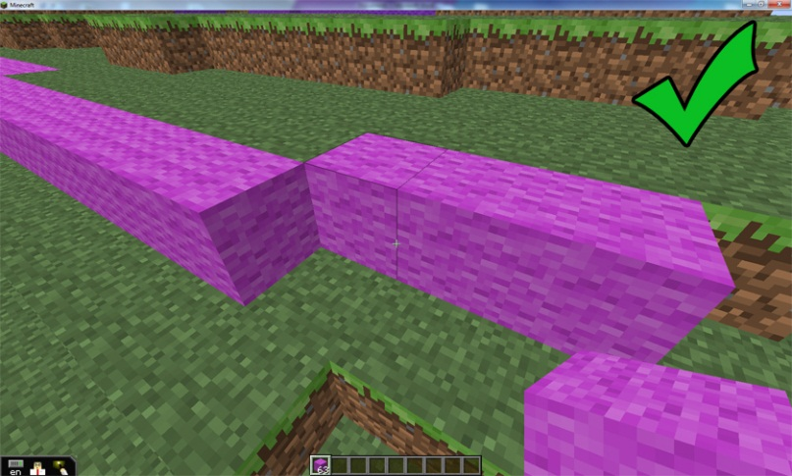

Minecraft Tips
- Right-click a chest to open it. You can then click and drag materials from the chest into your inventory. The bottom row of your inventory is what you can use in your hand.
- The “E” key opens your inventory. You can select what is in your hand by pressing the 1-9 keys.
- Right-click to place a block. Hold left-click to remove a block.
- You can see where your block will be placed by watching the black outline around the blocks.
- Communicate with your classmates – you’ll have to work together to complete the contour lines.

Credits
This MinecraftEdu map was designed by Yotam Haimberg as part of the Pixel Pushers project team at Carnegie Mellon University’s Entertainment Technology Center. The project team worked closely with MinecraftEdu to develop tools and lessons for teachers so they could easily integrate MinecraftEdu into their curriculum.
I’d like to thank:
- EduElfie for continuously thinking of new ways that Minecraft can be used. He had the thought the Minecraft lends itself well to contour lines and this lesson is an extension of that. His original video is available here: http://www.youtube.com/watch?v=qD2keQvu578

- The teachers at Elizabeth Forward Middle School for providing valuable feedback as well as a special thank you to Paul Callaghan testing the lesson with his students

- Joel Levin for his feedback on how to organize the map for a large class of students

- The entire Pixel Pushers team for their support and willingness to playtest early versions of the lesson!

