**Roman Architecture Lesson**

**OVERVIEW**

This is a guided exploration lesson intended to act as a three-dimensional model of Roman architecture, allowing students to walk through representations of key Roman structures: road, bridge, aqueduct, and villa.

**OBJECTIVE**

This lesson is intended to act as a supplement to textbooks and other materials that have introduced students to Roman culture and architecture. The lesson was envisioned as a more immersive diagram, allowing students to appreciate these structures spatially and in three dimensions.

An optional second part of the lesson encourages students to think critically about the function of the Roman villa, and how it might be adapted to another circumstance – for instance, a cooler climate.

**ACTIVITIES**

Students will enter the lesson on a road that leads to the villa. Students should proceed down the road, across a bridge and under an aqueduct before they reach the villa itself. As students explore these features in and around the villa, informational signs provide supplementary details and facts about these features.

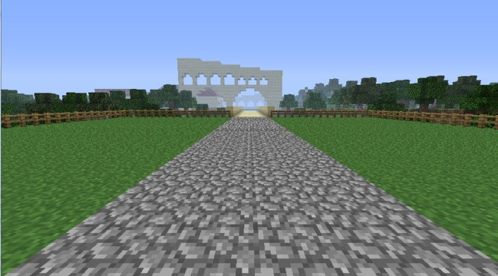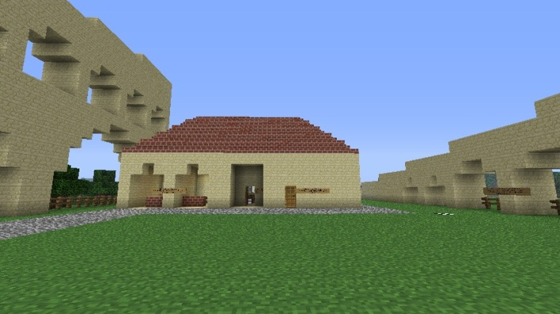

*Start Villa, surrounded by aqueduct*

Once students have explored the map, the teacher may open up the nearby building area. With the materials provided in chests, the students should be encouraged to build a Roman villa of their own – but one for a different circumstance. Challenge students to explain how and why they would change the design of the villa to meet this new circumstance. Would this new villa still be “Roman”? Why or why not?

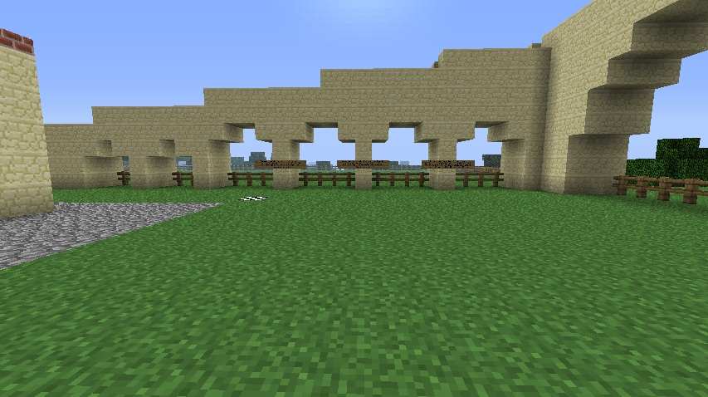

*Destroy these fences, above, to allow students into the building area.*

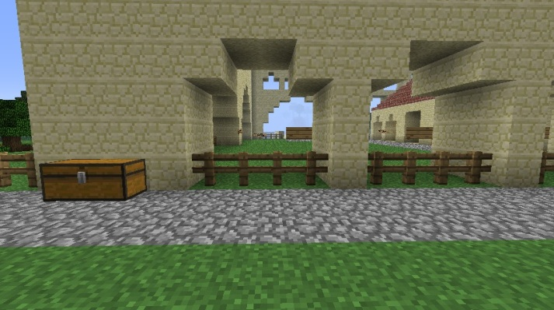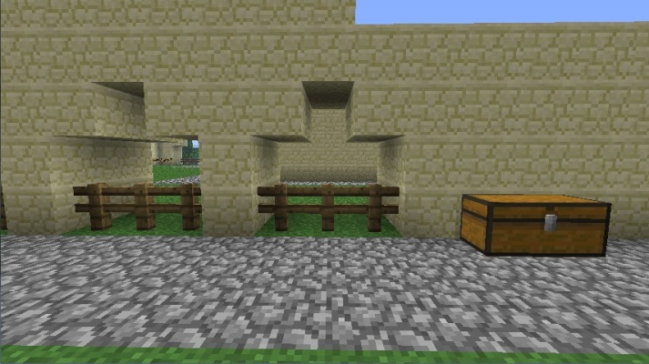

*Chests of building materials can be found on the other side of the aqueduct wall from the villa, in the Building Area.*

**LESSON PLAN**

The World options in the Teacher Menu: “Students Can Build” and “Health And Hunger” should both be toggled off for this lesson.

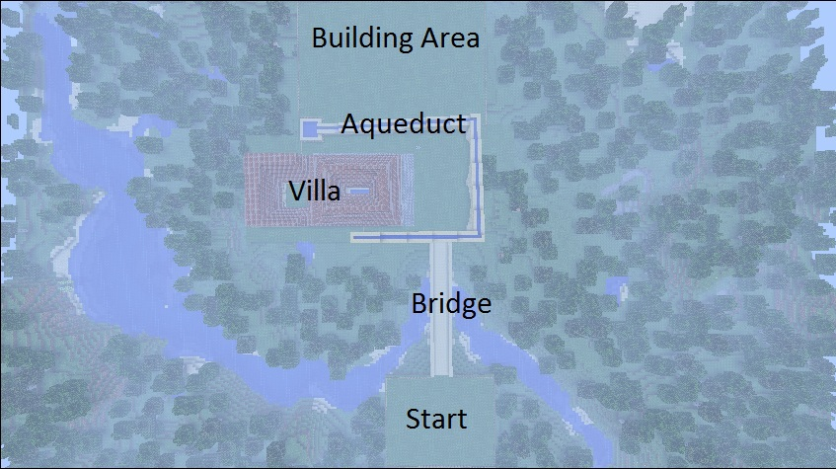

*Overhead Map of the Lesson*

Students will begin the lesson on a road that leads to the villa (at “Start”). Encourage students to walk across the nearby bridge to the villa grounds, and to explore the world around them. Fences and walls will prevent students from wandering away from the lesson’s content.

Once students have explored the area around the villa, you may want to open up the building area. To do so, simply remove some or all of the fence between the Villa and the Building Area, found under the arches of the Aqueduct.

Building materials will be found in chests in the Building Area, against the wall of the Aqueduct. Buried one block beneath the Building Area is a large plane of “Build Allow” blocks, allowing students to build within the enclosed Building Area even if the “Students Can Build” option is turned off.

**Student Handout**

Below is the student handout to go with this lesson.

**Roman Architecture**

The ancient Romans were master architects. Many of their engineering concepts formed a basis for modern architecture, while many of their roads and structures still stand today.

In this lesson, you’ll be exploring a Roman road, bridge, aqueduct, and a Roman villa.

The Roman villa served as a home to higher class or wealthier families. The villa in this lesson is built to scale – if each block is 1 meter cubed, a small villa would be about this size.

Roman roads and bridges helped maintain a large empire. With over 80,000 kilometers of paved roads, they helped to communicate and move armies and trade goods more quickly.

Roman aqueducts were mostly built underground, but needed to cross over rivers or canyons. Roman aqueducts needed to be built at an angle so that water would flow downhill, but needed to be as close to level as possible to bring water to a city over a long distance.

Arches were an important part of Roman architecture as they allowed the construction of large structures with less material than it would take to build a solid wall. In addition, no single part of an arch supports the weight above it – the weight above is distributed across the arch, helping to keep the structure stable.

**Movement & Building**

*Movement*

* Use the W, A, S, D keys to move, and the mouse to look around. Use spacebar to jump.

Later in the lesson, you’ll construct your own Roman villa with the rest of the class. The Roman villa in this lesson is built for a warm, Mediterranean climate. How would you build a villa for a cooler climate?

*Tips for building:*

* Right-click a chest to open it. You can then click and drag materials from the chest into your inventory. The bottom row of your inventory is what you can use in your hand.
* The “E” key opens your inventory. You can select what is in your hand by pressing the 1-9 keys.
* Right-click to place a block. Hold left-click to remove a block.
* You can see where your block will be placed by watching the black outline around the blocks.
* Communicate with your classmates – you’ll have to work together to complete a villa.

*Once you’ve finished:*

* How did you build this villa for a cooler climate? What did you change from the original villa, and why did you change that?
* Do you think this new villa is still “Roman”? Why or why not?