this issue

Open Source Revolution P.1  
IT Management Tips P.2  
Non-Profit Solutions P.3  
Trends & New Software P.4

UP+ newsletter #14

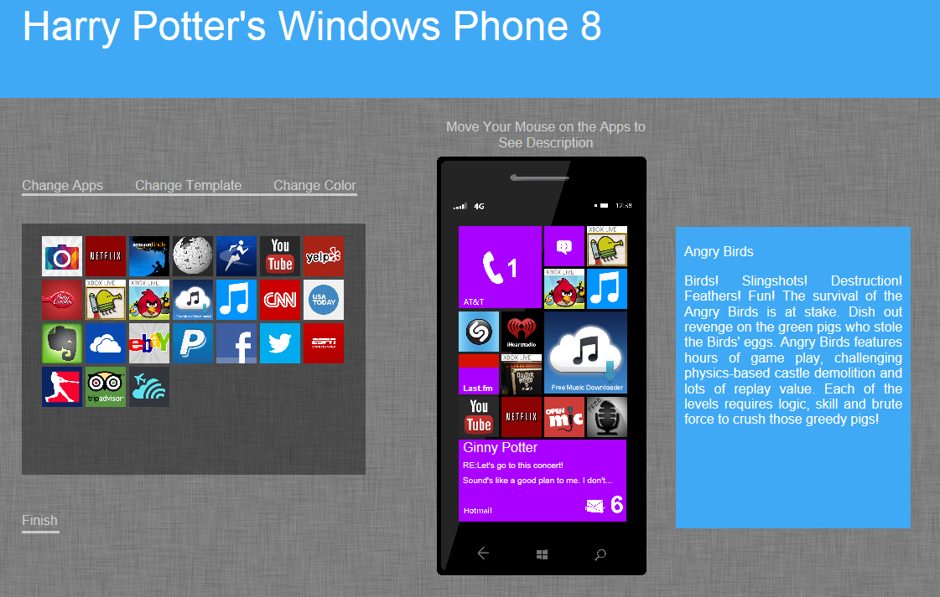Monthly Journal of Information Technology ISSUE 00 MONTH YEAR

Soft opening week

**Things done:**

Soft opening presentation and getting the feedback from the advisors, new set of pictures, polish on start screen control, published the survey

**Things to do:**

After getting enough data over the weekend, we will use the algorithm to run the data, and combined all part together. Send out the link to get feedback and playtest. Prepare for BVW show night to playtest and record video. Final tweak after Wednesday and start out documentation and final presentation.

Challenge:

How to prove that people loves it. By choosing the right screen, or ask them the feeling for the overall experience.

CUSTOM SOLUTIONS

Tincidunt ut laoreet dolore magna aliquam erat volut pat. Ut wisi enim ad minim veniam, quis exerci tation ullamcorper cipit lobortis nisl ut aliquip exit amet, consec tetuer adipiscing elit, sed diam nonummy nibh euismod tincidunt ut laoreet dolore magna aliquam . Ut wisi enim ad minim veniam, quis nostrud exerci tation ullamcorper. Et iusto odio dignissim qui blandit praeseptatum.

WEB SOLUTIONS

Tincidunt ut laoreet dolore magna aliquam erat volut pat. Ut wisi enim ad minim veniam, quis exerci tation ullamcorper cipit lobortis nisl ut aliquip exit amet, consec tetuer adipiscing elit, sed diam nonummy nibh euismod tincidunt ut laoreet dolore magna aliquam. Ut wisi enim ad minim veniam, quis nostrud exerci tation ullamcorper. Et iusto odio dignissim qui blandit praeseptatum. Ut wisi enim ad minim veniam, quis nostrud exerci tation ullamcorper. Et iusto odio dignissim qui blandit praeseptatum.