Week 4 Weekly report- team Up+

Things done this week:
- final version of team website, final version of flyer, poster, and logo
- submit the updated team description and logo onto ETC portal
- preparation for the 1/4 talk and presentation
- many deep brainstormings on the content of the experience, and later decided on making it with the journey look-like
- the potential platform will be on browser, however we could develop different versions for different platforms
- team pictures!!!
- 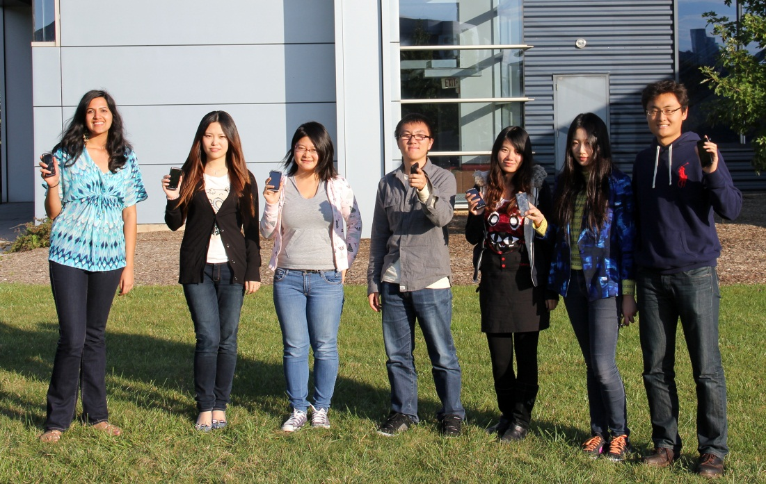
Plan for next week:
- got feedbacks from 1/4 and tweak the current idea
- discuss on what is good and bad parts about team work and communication so far
- separate the work into small teams
- make one or two fast prototypes
Challenge:
- how to make the experience more interactive, fun, informative and attractive

