Week6 Weekly report-team Up+
Things done this week:
- Basic control of the click and zoom in interaction using plain images
- Survey within ETC
- The survey to send out for later use, and started code it with HTML, PHP and MySQL
- The pre-set and post-set of data
- 15 pairs of pictures as potential settings in the environment
- We are ready to do the integration
To-do:
- Integration of the frontend and backend
- Send out the survey and analyze
- Implement the associate rule within any kind of language
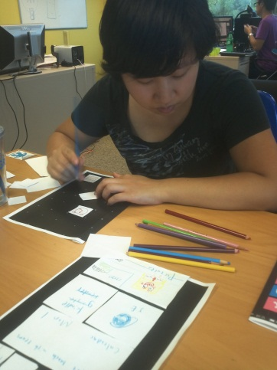
Challenge:
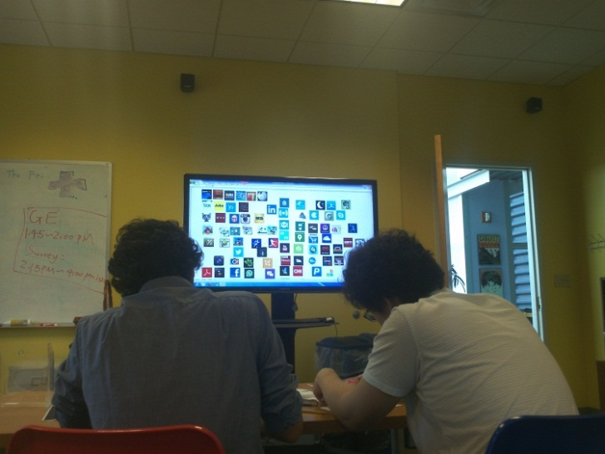
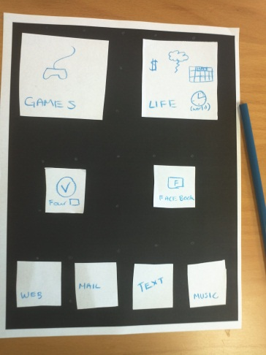
Using 2d programming perspective for 3d is time-consuming for us since we already tried out HTML and JavaScript for 2 weeks and the result is limited. So we should start thinking of how to make the frontend more interactive and fun. And after the data is collected next week, we may run the associate rule algorithm the first time, we may have to adapt the design of the experience according to it.

