InterACT Software Specification
Last Modified: 10/16/2001
By: Nate Jones

High-Level System Flow Diagram
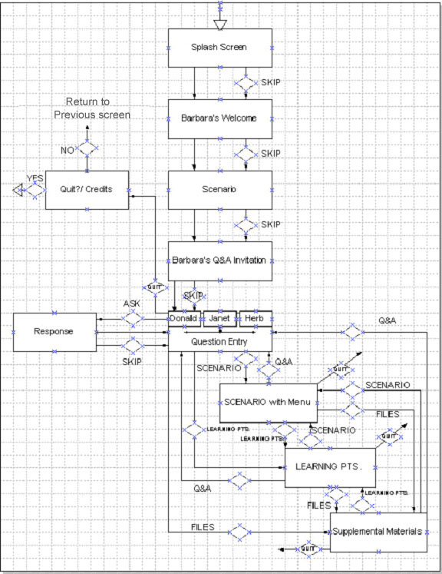

Summary of updates from previous semester:
Change music to something less copyrighted. (paranoia)

We’re looking into ways to (optionally) prompt the user with suggested questions. We feel there needs to be a way to show the scope of the answer database without frustrating the user (near

Misc UI updates:
Choosing No when asked if you’re sure you want to quit will return you to whatever menu you were at when you last hit the quit button (back to where you came from)
Scenario scene selection should rollover to an image from the scene
Continue the light blue border theme around small video:
(Give Barbara’s video a boarder)
User can select the character to ask a question by clicking on the image in the idle animation on the Q&A menu
Some manner of idle loop ( for Barbara’s learning points )
Add dedication to Paul Christiano (1942-2001)
Fixup credits to reflect two cycles of development
(add thanks to CIT as well)

Detailed Page Descriptions

1. Splash Screen

Description:
The splash page is the first page a guest sees when running the software. There is no interactivity. The splash page serves as a visual introduction to the software and presents the piece’s title, origin, and copyright information.

Content and Delivery:
Text: “The Carnegie Interactive Theater Initiative Presents…”, “A Talking To”
Background Music: The Beatles, “Come Together,” ©1969 Apple Corp.
<CHANGE>: undetermined music that’s more copyright-friendly.
Background Images

Menu Options:
None
Automatically transitions to Barbara’s Welcome page after a short time.

2. Barbara’s Welcome

Description:
Barbara explains the purpose of the software and introduces the scenario in a brief video clip.

Content and Delivery:
Video: Barbara’s Welcome

Menu Options:
- SKIP: stops video clip and goes to the Scenario page.

Automatically transitions to the Scenario page after Barbara’s Welcome clip ends.

3. Scenario

Description:
Guests view a video of a scenario written to raise awareness of diversity issues and provoke critical thought.

Content and Delivery:
Video: Scenario

Menu Options:
- SKIP: stops video clip and goes to Barbara’s Q&A Invitation page.

Automatically transitions to Barbara’s Q&A Invitation page after Scenario video ends.

4. Barbara’s Q&A Invitation

Description:
In a brief video clip Barbara
- invites guests to explore the characters perspectives by asking them questions about the scenario
- NOT IMPLEMENTED: explains how to access the supplemental materials, learning points, scenario, and quit using the menu.

Content and Delivery:
Video: Barbara’s Q&A Invitation

Menu Options:
- SKIP: stops video clip and goes to Question Entry page

Automatically transitions to the Question Entry page after video ends.

5. Question Entry

Description:
Guests ask the scenario characters questions by selecting a character, typing a question in a text box, and clicking on the ‘Ask’ button or hitting enter while typing in the question entry, text box. A video window displays a video clip showing all three characters seated together as if waiting for a question. Motion of the characters will increase the longer the guest stays on the Q&A page without asking a question.

The program will default to asking Donald (he’s first in line) a question when the screen is first entered. When the user makes subsequent visits to the Q&A, the question recipient will be the last person asked (selection state is retained).

Content and Delivery:
Video: (1) looping idle/ waiting movements

Menu Options:
- QUIT: stops video clip and goes to the Quit?/Credits page.
- DONALD Button: displays textbox, selection indicator, and ask button.
- HERB Button: displays textbox, selection indicator, and ask button.
- JANET Button: displays textbox, selection indicator, and ask button.
- ASK (or enter): sends guest’s question to synthetic interview code via the ActiveX control and and goes to the Response page.
- SCENARIO: stops video clip and goes to the Scenario With Menu page.
- LEARN: stops video clip and goes to the Learning Points page.
- SUPPL.: stops video clip and goes to the Supplemental Materials page.
i. Video: can select a character by clicking on his idle animation

6. Response

Description:
Guests hear the response to their question via three simultaneous video clips of each scenario character. The clip of the character being questioned is larger than the others and shot as a close up. The clips of the other characters are shot in three quarter view.

Content and Delivery:
Video: Trio of clips selected by synthetic interview based on the guest’s question.

Menu Options:
- SKIP: stops video clips and goes to the Question Entry page, same character as just asked.

Automatically transitions to the Question Entry page after response clips end.

7. Scenario with Menu

Description:
Allows the guest to re-view the scenario video. Guests are able to play the video from the very beginning or start at certain key points in the action. Links include:
- watch entire scenario
- Clip 1: Herb’s entrance
- Clip 2: Herb compliments Donald
- Clip 3: Team player?
- Clip4: Donald describes the joke
- Clip5 : Herb’s awkward recovery
- Clip6: Janet’s entrance
- Clip7: The problem with Donald
- Clip8: The complaints
- Clip9: Defensive
- Clip10: A racial issue
- Clip11: Getting hired isn’t everything
- Clip12: Larger issues at hand

Content and Delivery:
Video: scenario video with movie time markers.

Menu Options:
- CLIPS 0-12: stops any currently playing clip and begins scenario clip from the point specified.
- QUIT: stops any currently playing video clip and goes to the Quit?/ Credits page.
- Q&A: stops any currently playing video clip and goes to the Question Entry page.
- LEARNING POINTS: stops any currently playing video clip and goes to the Learning Points page.
- FILES.: stops any currently playing video clip and goes to the Supplemental Materials page.

8. Learning Points

Description:
Guests learn about different ways they can handle diversity issues when they arise from Barbara via several short videos they can choose to view. Links include:
- the impact of jokes and comments
- fairness
- the importance of numbers
- two-way communication
- the responsibilities of a supervisor
- timely feedback

Content and Delivery:
Video: multiple clips of Barbara discussing her learning points.

Menu Options:
- POINT 1-6: stops any currently playing sound or video clip and launches the selected clip.
- QUIT: stops any currently playing video clip and goes to the Quit?/ Credits page.
- QUESTIONS: stops any currently playing video clip and goes to the Question Entry page.
- SCENARIO: stops any currently playing video clip and goes to the Scenario With Menu page.
- SUPPL.: stops any currently playing video clip and goes to the Supplemental Materials page.

9. Files

Description:
Guests are able to browse through several pieces of evidence relevant to the scenario including:
-Don’s six-month review, bio, and resume
-Jan’s six-month review, bio, and resume
-Herb’s bio and resume

Content and Delivery:
Text in PDF format: reviews, bios, and resumes as listed above.
TODO: change the format to something besides pdf
(acrobat’s plugin has a splash screen on startup,
and also lots of cluttering buttons along the top of the interface).

Menu Options:
- QUIT: closes any open document and goes to the Quit?/ Credits page.
- DONALD: displays links to Don’s files.
- JANET: displays links to Jan’s files.
- HERB: displays links to Herb’s files.
- DON’S 6MO REVIEW: opens Don’s six-month review document in a scrollable window.
- DON’S BIO: opens Don’s bio in a scrollable window.
- DON’S RESUME: opens Jan’s resume in a scrollable window.
- JAN’S 6MO REVIEW: opens Jan’s six-month review document in a scrollable window.
- JAN’S BIO: opens Jan’s bio in a scrollable window.
- JAN’S RESUME: opens Jan’s resume in a scrollable window.
- HERB’S BIO: opens Herb’s bio in a scrollable window.
- HERB’S RESUME: opens Herb’s resume in a scrollable window.
- Q&A: closes any open document and goes to the Question Entry page.
- SCENARIO: closes any open document and goes to the Scenario With Menu page.
- LEARNING POINTS: closes any open document and goes to the Learning Points page.

10. Quit?/ Credits

Description:
The last page guests see before closing. Confirms that guests really want to exit the program. Credits automatically begin to scroll Hollywood-style upon reaching the page.

Content and Delivery:
Text: Scrolling credits
Background Music

Menu Options:
- YES: stops the credits if still playing and exits the program
- NO: stops the credits if still playing and goes to the previous page.

Design Decisions

Facilitator
Unlike the live version of the performance, a facilitator character will not be used on the DVDROM. Instead synthetic interview and software will be used to direct guests’ questions and introduce learning points.

Humor
Humor will be used very cautiously as the subject matter of the DVDROM is serious and should be taken as such.

Learning Points
Learning points will be conveyed in two ways. 1) Guests can listen to video of Barbara in the Learning Points section of the software. 2) If the guest asks a number of questions that do not illuminate any of the learning points, then the characters will enter a spontaneous discussion on the Question Entry page that will provoke questions that hit a learning point.

Note: Point 2 was not implemented by the first cycle group; and rather than try to film a number of semi-spontaneous exchanges to prompt the proper questions, we will have some way (un-determined as of yet) to give the user suggested questions. We need a way to offset the inherent frustration where the phrasing of a question keeps the user from getting a response (or getting the proper response).

Location Change
The scenario will be filmed in a standard office setting and the responses to questions will be filmed in a studio on a plain black background. The change in setting is intentionally different to key the user into a change in interaction and allow us to more easily shoot more responses in the future.

Point Of View
The scenario will be shot in a cinematic way to engage the audience. Responses will be shot in a non-dynamic way with a close-up on the responder and three-quarter view shots on the other two characters. Spontaneous conversation and idle waiting motion will be filmed in a non-dynamic way with all three characters visible in a seated position and displayed in a letterbox style to save space on the DVDROM.

User Role
The DVDROM will not place the user in any particular role as this may introduce bias by slanting the types of questions a guest asks.

Video Controls
Standard video controls such as play, stop, pause, and a scrub bar will not be included to prevent the user from changing how the videos are conveyed.

All videos will automatically begin playing as soon as they are displayed.

To Be Tested

1. Understated skip button – Do first time users skip through important information?
2. Appearance of menu – Would it be beneficial to display the menu as Barbara mentions it during her invitation to the Q&A even though it will only be active after reaching the Question Entry page?
3. Persistent quit button – Should the user be able to quit anytime including the response page or would removing the quit button from the menu be confusing to the user?

4. Text
Will showing the text transcriptions of the response clips along with the video be distracting or will it help make the material more accessible and digestible.

5. Headshot Q&A icons
Will users find it cumbersome to click on the headshot of the person to be questioned? Does leaving the past selection active help? Is the icon system intuitive? Proposed alternative: having three text boxes present on the page.

