Exercise 2 – Character Animation
- File → New World
- Templates → choose “dirt” floor →Press
- In the World View Panel→ Add Object
- In the Arts Assets folder choose
- Press  button.
- click on the and open the detail panel of the method
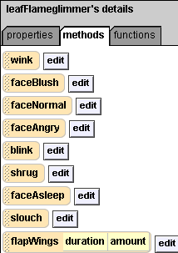
drag the methods such as faceBlush, shrug, slouch, and flapWings, drop the methods into the “DoNothing” Area in World.my first method.
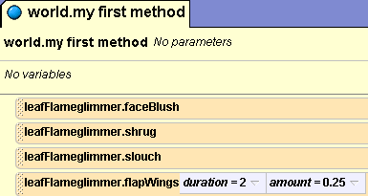
- Click 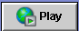 to see the animation now.
- In the World View Panel→ Add Object
Move the Camera (blue control button)
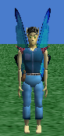to the front of the character

- Choose Quad view, use these two mouse control (scroll view, zoom in and out) to move your character to the middle of four side of view.

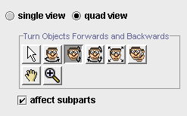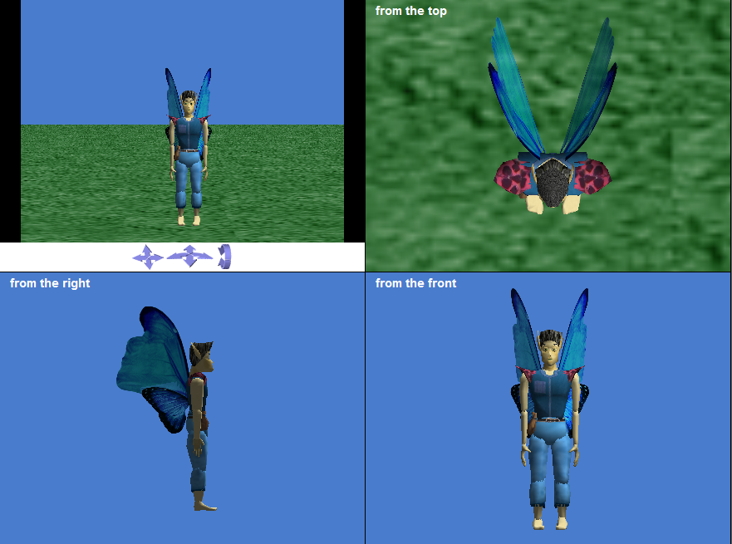

- choose affect subparts
- 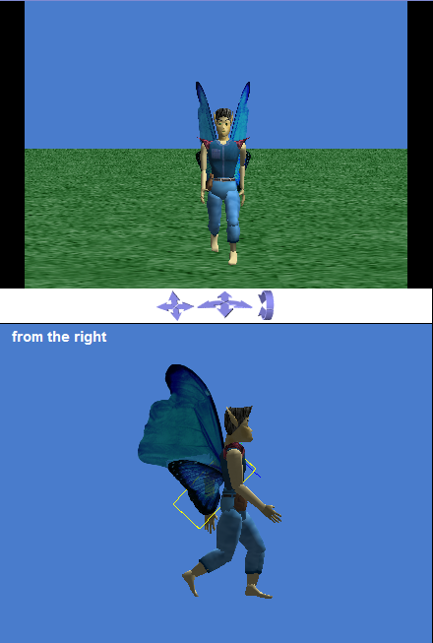
Turn the character leg(lower leg) and arm(lower arm) to forwards and backwards.
Make it looks like a walking pose (Make sure your character face to you)
- Ctrl+click on the character → choose capture pose
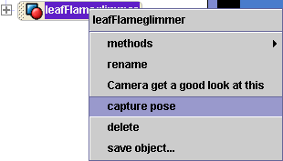

- In the detail panel, properties page, type the pose name to WalkingPose1
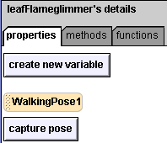

- 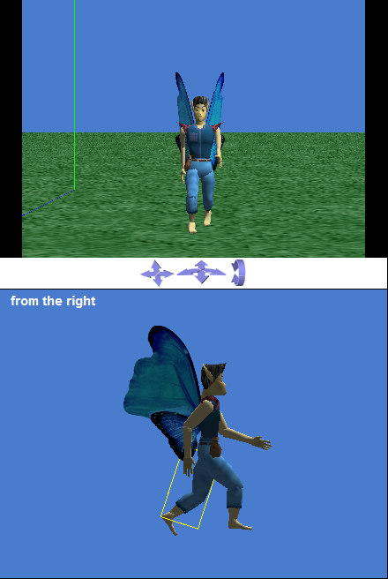 Turn the character leg(lower leg) and arm(lower arm) to forwards and backwards.
Make it looks like a walking pose

- Ctrl+click on the character→choose capture pose

- In the detail panel, properties page, type the pose name to WalkingPose2
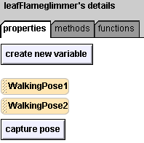

- Press button.
- In the detail panel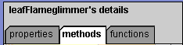
drag method into script editor
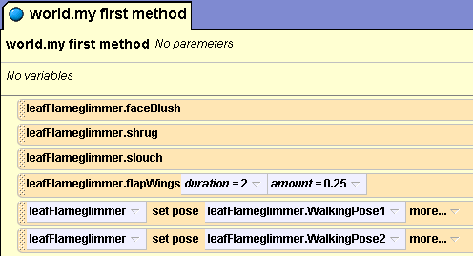
Choose walkingPose1 and walkingPose2
19. Drag a say method and choose other to type sentences

20. Click to see the animation now.

Exercise 2 – Advanced Character Movement

During this exercise, you will learn how to move your character easily in different 3 positions

- Open World Editor by pressing
- Select in the right panel in order to see detailed control panel.
- Place your character in the world and Locate it in the 1st position you want.
- Press  in order to save current position
Make sure you correctly choose the character in the object tree such as
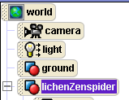
If the world object is selected, you cannot save current position of the character correctly

- Change the name of the dummy into “angel_pos1”
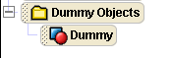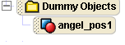
- Locate the character in the 2nd position you want
- Press in order to save current position
- Change the name of the dummy into “angel_pos2”
- Locate the character in the 3rd position you want
- Press in order to save current position
- Change the name of the dummy into “angel_pos3”
- Go back to Main Editor by pressing 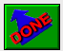
- Now it’s time to do programming!
- In your character’s method panel, find ‘set point of view” Method(or action) and drag it to “world.my first method”
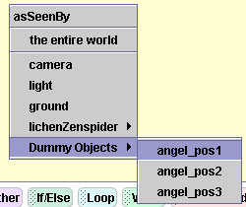
- Choose “angel_pos1” now if you play your world, your character will move to “angel_pos1”
- Drag “set point of view” method and drop in to “world my first method” again
- Choose “angel_pos2”
- Drag “set point of view” method and drop in to “world my first method” again
- Choose “angel_pos3”

- Now your “world.my first method” should look like this

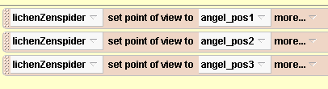

- Press ‘Play’ !
- In order to make it loop, Drag ‘Loop’ statement at the bottom of the Alice window and drop into ‘my first method’ choose ‘infinity’
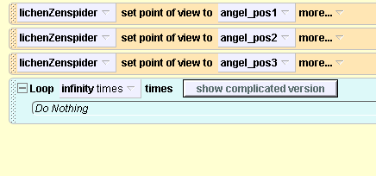
23. Now Drag and drop every ‘set point of view to’ method into loop statement
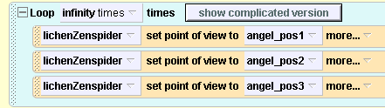

- (Optional) You can put ‘Wait’ statement at the bottom of the Alice window to put interval between movement
- Press ‘Play’ !

