Exercise 3 - Camera Movement - Part 1

During this exercise, you will learn how to make camera follow the character

- Drag ‘Camera’ and Drop into ‘my first Method’ right in front of the Loop statement.
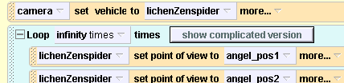
- Choose the entire character of lichenZenSpider
- Press Play! Now the cam follow your character
- Right Click on ‘set vehicle to’ statement and choose ‘Disable’ or you can ‘set vehicle to’ the world itself. Now it won’t follow character anymore.
- Drag ‘turn to face’ method of the camera and put the every end of ‘set point of view to’ method
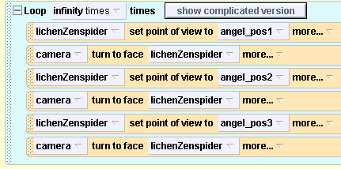
Press Play! Now the cam turn to face your character
- (Optional) Try This!
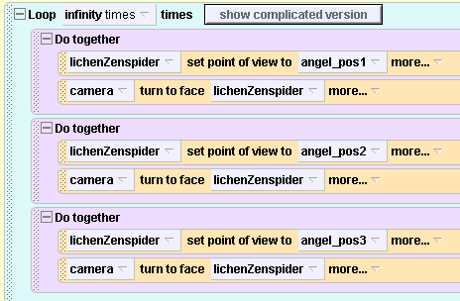
Exercise 3 - Camera Movement - Part 2

During this exercise, you will learn how to set the different positions for different camera view easily. Using this technique, you can implement different frames for your game in the same world.

- Open World Editor by pressing
- Press in the right panel in order to see detailed control panel.
- Press 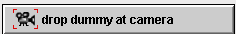 to store current position of the camera for frame 1
- Change the name of the dummy into “camera_frame1”
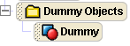 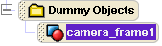
- Right Click on the camera in object tree and
choose ‘methods -> camera move -> right -> other…”

- Input 100 to move right. 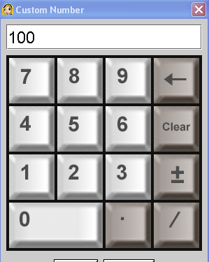
- Press to store current position of the camera for frame 2

- Change the name of the dummy into “camera_frame2”

- Right Click on the camera in object tree and
choose ‘methods -> camera move -> right -> 100 “
- Press to store current position of the camera for frame 3

- Change the name of the dummy into “camera_frame3”

- Right Click on the camera in object tree and
choose ‘methods -> camera move -> right -> 100 “

- Now that you store all positions for each frame, you can move your camera wherever you want using advanced panel
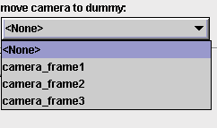
- Go back to Main Editor by pressing 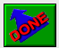
- Set up environment in different location for each frame.

- Now it’s time to do programming!

- Drag ‘camera’ in object tree into your ‘my first method’

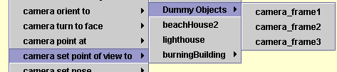
18. Choose ‘camera_frame 1’
- Put 2 more ‘set point of view’ methods for ‘camera_frame2’ and ‘camera_frame3’
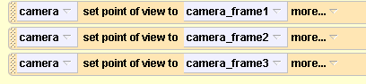
- Now you can switch from one frame to the other.
- (Optional) Try This! For smoother transition between frames
